Evidences and Instructions

As soon as the program gets start, a menu is displayed. The first option will display a list of categories which will be used later for each item input (important because of the taxes for each type of item at the end for the receipt).

Enter the number ‘1’ then hit enter to display all categories as below:

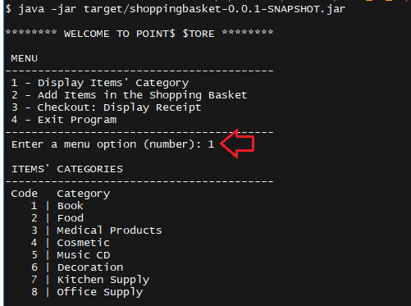

Bellow that, the Menu will be displayed again then enter the second option (number 2).

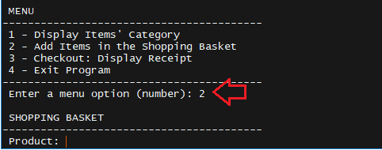

Now, fill the fields out according to their labels to input a new item:

Example:

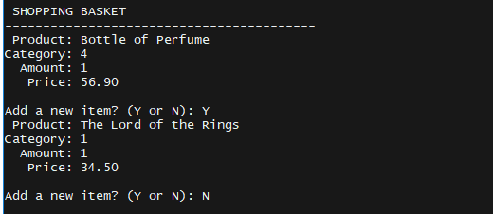

Once it’s done you can continue adding more items to your shopping basket entering ‘Y’ or just exiting the section entering ‘N’ then hitting the Enter.

After selecting ‘N’ to end to items adding, the Menu will be displayed again and then the option number 3 can be entered (Checkout: Receipt).

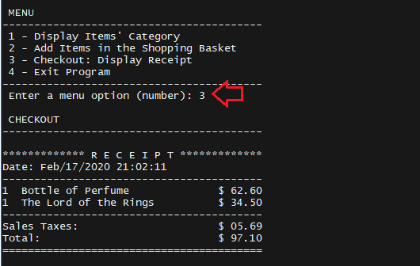

Once the checkout prints out a receipt the basket turns empty and new items can be added for a new shopping basket. Otherwise, the option number 4 can be entered to exit the program as below:

